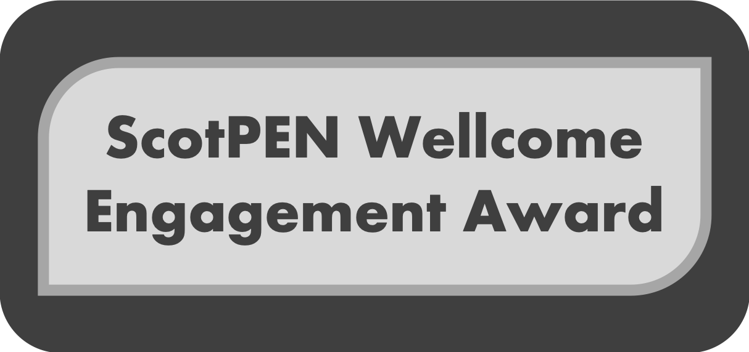

Application Form
2019-2020 Round 1
Open August 2019

This form, plus any letters of support from project partners, must be submitted electronically via your Institutional public engagement team as a single PDF file.

Full guidance notes, including privacy notice and details of institutional public engagement contacts can be found at www.scotpen.org/swea.

Key Dates
The closing date for applications is 5pm on Friday 25th October 2019. The start date of this award can be no sooner than 25th February 2020.

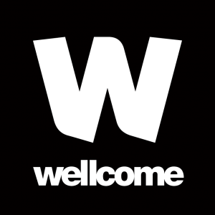

- Project overview

Title of the proposed project
Proposed start date
No earlier than four months after application deadline
Proposed duration of project
May not extend beyond the end date of your Wellcome award
Total funding requested
Please provide detailed breakdown in Section 4

- Applicant Details

Lead Applicant

Lead Applicant
Full name
% Ownership of engagement project
Wellcome grant title and number | for example, 111111/Z/11/Z
Grant end date
Research Institute/School/ Department/Division
University
Email address

Co-Applicant/s (see Guidance notes for definition) Please list details of all additional project co-applicants. Add further tables as required. Please leave blank if you have no co-applicants.

Co-Applicant 1
Full name
% Ownership of engagement project
Research Institute/ School/ Department/Division
University
Email address

Project Partner/s (see Guidance notes for definition) Please list details of project partners (organisations or individuals) with significant involvement in the project. Add further tables as required. Leave blank if you do not have any partners.

Project Partner 1
Full name
Job title
Organisation
Project role (e.g. delivery partner; public engagement support)
Funding to be transferred to partner? | Yes/No (delete as appropriate. Please provide details in Costs Requested)
- Background information
Summarise your main Wellcome award for which you are requesting SWEA funding. Indicate progress made to date and how this engagement activity complements your research (maximum 300 words).

- Project summary

Please provide an outline of what your successful engagement activity will look like, and what you will have achieved (Summary for external publication; maximum 250 words).

- Project Description
Provide details of your public engagement proposal (overall maximum: 850 words)

- What is the purpose of your engagement? What change do you want to achieve and why is this needed? Who do you want to reach and why do you want to engage with them? Consider the outcomes for the audience as well as any impact on you, your research, your institution and beyond.

- What is the project you will deliver? Include rationale for why your methods are appropriate for your chosen audience and outcomes, and how you will work with any external partner/s.

- How will you evaluate your outcomes and share this learning?

- What public engagement experience do the applicant(s) and partners bring, and how will the proposal will develop capacity?

- Costs Requested
Provide a high-level budget breakdown and justification for costs requested.
Add more rows as required.

Expenditure | Amount (GBP) | Justification

